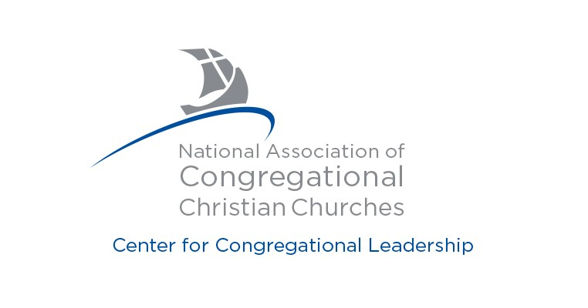

Excellence in Ministry Awards

Nomination Form

Help us celebrate excellence in ministry. The NACCC wishes to recognize leaders and/or innovators who have made significant contributions to Congregationalism. The Nominees should exemplify personal commitment to the principles of Congregationalism of faith, freedom and fellowship.

Nominations may be made by churches or individuals. Supporting documentation may also be submitted to assist the VMC in their selection process. This may include letters of support and/or articles about the nominee.

These yearly awards will be given at the discretion of the Vitality Ministry Council (VMC). Submitted materials will be kept confidential and become the property of the NACCC.

DEADLINE FOR NOMINEE CONSIDERATION IS APRIL 30.

For consideration, return this nomination form and any supporting documents to:

Center for Congregational Leadership Burrage Library - Olivet College
320 S. Main Street Olivet, MI 49076

E-mail: msteele@naccc.org Fax: (269) 749-7290

Reset Form

Marian Bradshaw Award | Harry R. Butman Award | Jennette Butman Award
- Ordained minister  - Personally committed to Congregationalism  - Preference given, but not limited, to a minister of the State of Maine  Award: $500. Award to be used for continuing education other than a professional degree program. | - Ordained minister who has served at least ten years in an NACCC church  - Personally committed to the principles of Congregationalism  Award: $500. This award is intended to provide ministerial assistance to lift and encourage a minister. | - The spouse of a Congregational minister who has served an NACCC church for at least 10 years and has assisted their spouse in ministry.  Award: $500. Awarded on the basis of need, merit or outstanding achievement

Nominee's Name

Church Membership

Nominee's Address

City State Zip Code

Phone
E-Mail

Nominator's Name

Church Membership

Nominator's Address

City State Zip Code

Phone
E-Mail

Please describe the nominee's personal commitment to Congregationalism and other achievements that further the principles of Congregationalism.

